SMALL FUNCTION GENERATOR
Sumaiya mansoor khan(2024601)
Safia malik(2024555)
ELECTRICAL ENGINEERING
GIKI

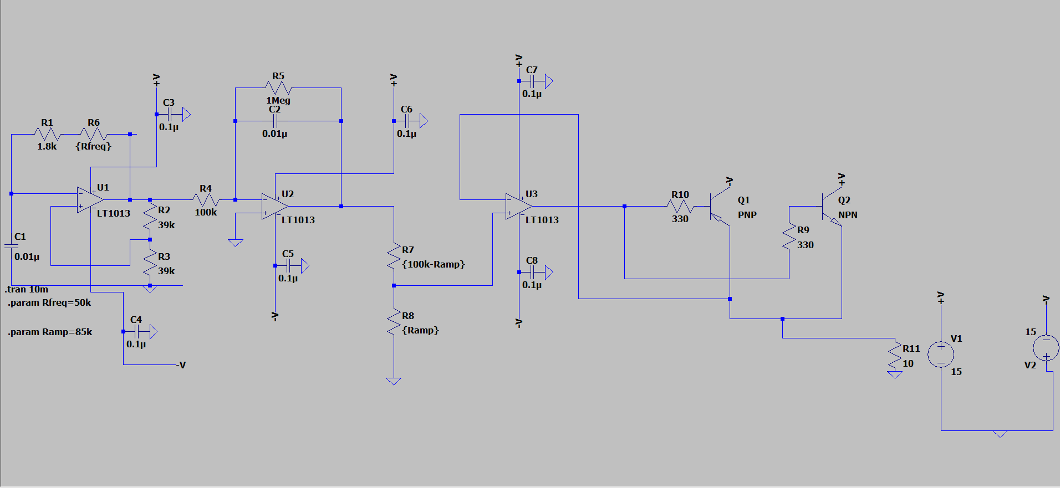
— This project focuses on the design, simulation, and hardware implementation of an analog signal generator capable of producing stable Square and Triangle waveforms. Unlike standard low-power signal generators, this system features a High-Current Output Stage specifically designed to drive low-impedance loads, such as a 10$Ω$ resistor, with a current delivery of up to 500mA.The project bridges the gap between low-level analog signal processing and power electronics by combining precision op-amp circuits with a discrete transistor "push-pull" power buffer.

Keywords
Function Generator, Op-Amp Integrator, Schmitt Trigger, Push-Pull Power Stage, Frequency Control, Analog Signal Processing, LTspice Simulation.

Introduction
Signal generation is a fundamental requirement in electronic testing and circuit design. While many function, generators exist as integrated circuits, building one from discrete op-amps and transistors provides deep insight into analog signal processing and power amplification. This project focuses on the design and implementation of a high-current function generator capable of producing both triangle and square waves at a target frequency of 10kHz, with a robust power stage designed to drive low-impedance loads down to 10Ω.

Overall System Description
The system consists of the following major blocks:
- Square wave generator (Schmitt trigger)
- Triangle Wave generator (Integrator)
- Frequency control
- Amplitude control and buffer
- High current power stage

Circuit Design and Implementation
Signal Generation (Schmitt Trigger & Integrator)
Fig. 1. LT Spice simulation
- U1 (Schmitt Trigger): Resistors R2 (39k) and R3 (39k) set the hysteresis thresholds. With a ±15V supply, the output snaps between the rails, providing a stable square wave.
- U2 (Integrator): The square wave is fed through R1 and the frequency potentiometer R6 (Rfreq) into capacitor C2 (0.01µF). This integration process creates the triangle wave slopes.
- Frequency Tuning: The frequency is determined by the RC time constant of (R1+R6) and C2. Adjusting the {Rfreq} potentiometer allows for precise control around the 10kHz center frequency.
.Output Buffering and Power Stage
To prevent the load from affecting the oscillator's frequency stability, the signal is passed through U3.
- Amplitude Scaling: Potentiometer R8 ({Ramp}) allows the user to adjust the peak-to-peak voltage of the output.
- Push-Pull Muscle: Transistors Q2 (NPN - BD139) and Q1 (PNP - BD140) handle the current. Q2 "pushes" current during the positive cycle, while Q1 "pulls" current during the negative cycle.
- Load Handling: Base resistors R9 and R10 (330Ω) limit the current from U3, allowing the transistors to safely drive the 10Ω load (R11) with up to 500mA of current.

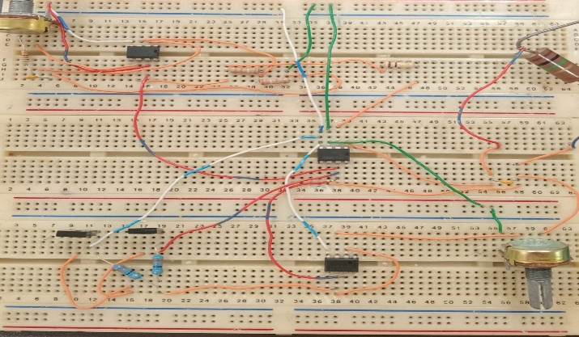
Fig. 2. Hardware

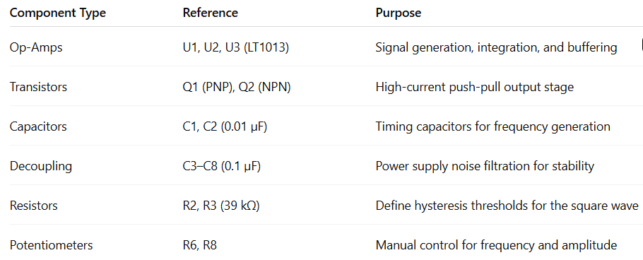Calculations and Design Values

Frequency ($f$): Calculated using the formula $f \approx 1 / (4 \cdot R_{total} \cdot C)$, where $R_{total}$ is the sum of R1 and the pot Rfreq.

Hysteresis ($\beta$): Set by $R3 / (R2 + R3) = 0.5$. This ensures the triangle wave swings to half the supply voltage before the square wave flips.

Output Power: Designed for $P = I^2 \cdot R$. At 500mA into 10Ω, the stage handles significant power, requiring the BD139/140 to be used with heat sinks in a physical build.

Simulation and Results
The project was validated using LTspice (as seen in the provided schematic). The .tran 10m command was used to observe several cycles of the 10kHz waveform.
- Square Wave Output: Observed at the output of U1 with sharp transitions.
- Triangle Wave Output: Observed at the emitter junction of Q1/Q2, showing linear ramps and adjustable amplitude.
.
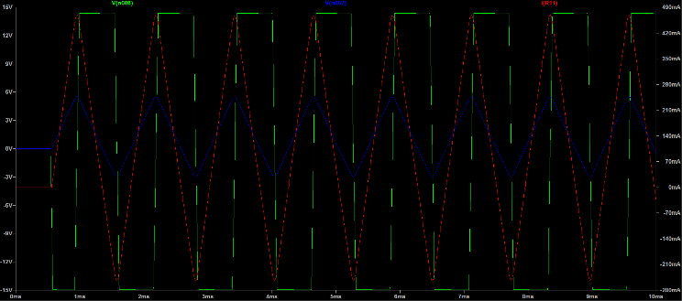

Limitations and Future Scope
Crossover Distortion: The current Class B push-pull stage may exhibit minor crossover distortion at the 0V crossing.
Thermal Management: Driving 500mA continuously into 10Ω generates heat; future versions should include active cooling.

Expanded Range: Adding a rotary switch to swap C1/C2 values could expand the frequency range from Hz to MHz.

Conclusion
This project successfully demonstrates the implementation of a high-current function generator. By using a Schmitt Trigger/Integrator loop, stable 10kHz waveforms were achieved. The addition of a discrete transistor power stage ensures the device is practical for driving real-world low-impedance loads, bridging the gap between low-power signal processing and power electronics.
.

References
[1] GeeksforGeeks, "Schmitt Trigger," GeeksforGeeks Electronics Engineering, Jul. 23, 2025. [Online].
[2] Electronics Tutorials, "Op-amp Integrator," Electronics Tutorials, 2025. [Online].

Fig. 3. Simulation Result

